Fieldwork Plan
Faculty of Science & Technology

This form is to be completed by the Onsite Activity Leader (OAL) and submitted to the final approver (the respective member of the Executive) at least two weeks prior to the trip.
For safety reasons, only fieldwork 50km< (or 1 hour away from base or not on open water activities) will be allowed for solo participants. In the event of a solo participant undertaking fieldwork, they are considered the Onsite Activity Leader. Remote fieldwork will not be permitted for participants travelling alone unless special arrangements have been made to minimise the risks.
The Fieldwork Plan is considered completed and approved when all signatures have been obtained. Completed forms and associated documents must be emailed to fst-support@cdu.edu.au
Research Project Name/Unit of study/ Project Name
Remote First Aid Officer
Fieldwork Description
Must reflect the Fieldwork Risk Assessment.
Be descriptive but not exhaustive.
Departure from base | Date |  |  | PTA #
Departure from base | Time
Return to base | Date
Return to base | Time
Onsite Activity Leader (OAL) details  *OAL must be a CDU employee and ensure that there is at least one traveller with Remote First Aid Qualifications | Name
 | Landline
 | Mobile
 | Satellite Phone
Onsite Activity Leader’s Supervisor/ Discipline Chair or Institute Director | Name
 | Contact Numbers | B/H
 | Contact Numbers | A/H
Check-in contact at base (CDU)  Check-in persons must be familiar and follow the check-in procedure, including escalation of failure to check-in reporting, see attachment E. All OAL must ensure check-in contact have been notified of the proposed travel. | Name
 | Signature
 | Contact Number
 | Check-in Time | Check-in time is 6-7pm daily unless otherwise arranged
Fieldwork location(s) and travel route(s) | Map(s) attached indicating location/GPS points/map references of site(s)  Map(s) attached indicating the exact planned route(s) to site(s)
Transportation Details  If taking more than one vehicle attach details separately. Private vehicle - must attach copy of form  CDU Application to Use a Private Vehicle for Official Purposes | CDU Vehicle  Booking Ref.  Rental Vehicle  Booking Ref. and Company  Private Vehicle  (ensure appropriate approvals have been obtained to travel on a private vehicle)  Details (owner, etc.) |  | Make
 |  |  | Model
CDU Boat CDU Other  Other (such as rental boats) |  |  | Rego No.
Description/Model |  |  | Colour or other details

Details of Participants
Must include all participants including Onsite Activity Leader. If more than ten participants – attach a separate list.
Note: If this is a trip for an undergraduate teaching unit and more than nine students will participate– attach a copy of current class list indicating only the actual participants and enter below as: (ENV101 class list attached).
All participants must have an approved Fieldwork Participant Form on file, submitted once within the current calendar year. If participants have not completed this, or individual details have changed they must submit with the Fieldwork Plan.
 | Full Name of Participant | Designation | Phone Number B/H | Personal Contact e.g. mobile
1
2
3
4
5
6
7
8
9
10
Fieldwork Participant Forms are only valid, only if assumptions or conditions hold throughout the year. Any variations to Participant’s fitness or medical conditions or the nature of fieldwork activity after submission must be discussed with the relevant Onsite Activity Leader before commencing fieldwork.
Does any participant have any medical issue that needs to be monitored throughout this fieldwork activity? (for further information, enquire with the participants or refer to their Fieldwork Participant Form). Yes No
DAILY MOVEMENT PLAN (Please tick as Check-in in actioned)
Depart from | Depart date | Depart time | Arrive at | Arrival date | Arrival time | ACCOMMODATION  (as applicable) | Accommodation Phone No. | Check- in (tick)
OTHER AUTHORITIES and CONTACTS
This list must include all other contact persons or companies who must be made aware of the activity taking place, its location or have some other interest in it. Example: Local Park Ranger/Local Police/Fire Station/Indigenous Community Liaison/ Landowners/Government Department/Private Company.
Full Name of Authority/Contact | Contact Name | Phone (B/H) | Other contact e.g. Mobile Phone No(s)

Checklist and Declarations
The following Field Trip Forms have been completed and attached (Please tick):
FIELDWORK RISK ASSESSMENT Fieldwork Participants Form (if a current one not on file)
Map of field trip locations New participant - Induction, field or remote work

As applicable (complete and/or attach):
TRAVEL HAS BEEN BOOKED THROUGH CTM
Approval memo for travel to countries with DFAT Warning Level 3
Relevant pre-approvals given by supervisor, project manager, director or discipline chair.
APPLICATION TO USE A PRIVATE VEHICLE FOR OFFICIAL PURPOSES – one for each vehicle
Relevant forms, licenses and certifications (e.g. 4X4 licence, AMSA certification, Dive Forms, Remote First Aid Certificate, etc.)

Onsite Activity Leader’s Declaration:
I declare that the above Fieldwork Plan and associated Fieldwork Risk Assessment have been completed to the best of my knowledge and any other situations/risks have been discussed prior to departure with my supervisor or other CDU contact person.
I acknowledge that I have a responsibility to work safely in the field, taking reasonable care to protect my own health and safety, and that of all other participants and the public. I undertake to personally check the safety equipment and safety procedures required for this field trip.
I am aware and understand the responsibilities I hold as an Onsite Activity Leader, including managing associated risks and safety procedures and understanding the health conditions of those travelling. I have made adequate provision for basic first aid.
I understand that it is my responsibility to ensure that the fieldwork party understand their responsibilities and are sufficiently briefed and appropriately trained for the fieldwork activity and in related emergency procedures. I will reinforce compliance with all procedures and directions as outlined in the University’s and Faculty policies, manuals, procedures, and codes of conduct relating to fieldwork.
I understand that it is mandatory that I as the Onsite Activity Leader am solely responsible for contacting the nominated CDU contact (check-in officer as per Fieldwork Plan) daily and upon our return to base. I understand that if contact is not made for any reason either throughout the trip, or upon return to base that the CDU emergency procedure will be activated.
Name: Signature:
Date:

As the supervisor of the Onsite Activity Leader, I declare that I have thoroughly checked this Field Trip Plan and associated Fieldwork Risk Assessment. I have discussed any other situations/risks prior to departure with the Onsite Activity Leader. I acknowledge that I have a responsibility as a Supervisor to ensure that all controls are in place for any foreseeable risks and that safety procedures required for this field trip are appropriate and in place.
Name: Signature:
Date:
Onsite Activity Leader’s Supervisor/Project Leader

Final Approval if different from supervisor (Discipline Chair/ Director / Faculty Manager on behalf of the PVC):

Name: ________________________ Signature: _________________________ Date:_____________________

FIELDWORK RISK ASSESSMENT

Section/Organisational details
Faculty/Organisational/Research Area: |  |  | Faculty of Science & Technology |  |  |  |  | Activity Dates:
Fieldwork description: | (Insert Fieldwork description) |  |  |  |  |  | Revision #: |  | Version
Prepared by: |  | Signature: |  |  | Date: | / / | Is this a new JSEA |  | Yes No

INSTRUCTIONS
Fill in the top section including a TITLE and /Organisational/Research Area and who prepared the document.  Tick off the PPE that will be required for the activity.  Fill in the Tasks/Activity down the left-hand column.  Identify all the HAZARDS for each Task/Activity and note them down in the HAZARD column for each Task/Activity. Do this as a group for best results.  Identify what the RISKS are for each HAZARD. The RISK is the impact or potential consequence of the HAZARD impacting on a person(s). Do this as a group for best results.  Develop CONTROL measures to mitigate the likelihood and potential consequences of the HAZARD. You need to do this as a group and write them down in the CONTROL column against each RISK.  YOU MUST USE THE HIERARCHY OF CONTROLS TO DEVELOP CONTROLS  HINT: When developing CONTROLS think about whether they are available, will it control the risk as intended and who is responsible. | Wherever possible try and include a control above the red line (see diagram). This will ensure your controls are not exclusively reliant on human behaviour to be effective.  Use the 5 X 5 Risk Matrix at the back of the document to rate the risks once you have confirmed the controls. Some guidance is provided.  The Risk Rating Process and the next step - confirming whether the RISK has been controlled SO FAR AS REASONABLY PRACTICABLE (SFARP) should be done as a team.  You must determine and state in the column provided who is responsible for ensuring the controls for each HAZARD/RISK are implemented.  REVIEW this completed document when you have completed establishing all the controls to see if anything has been missed i.e.  a minor task/activity  a control not available  a CHANGE in circumstances | 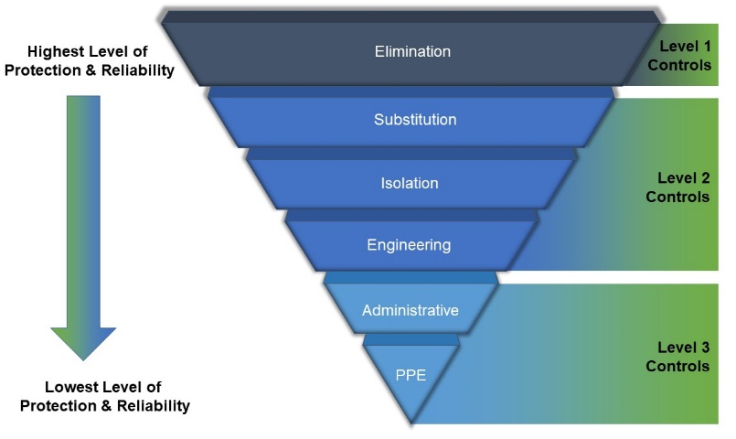
L = Likelihood C = Consequence R = Risk Rating SFARP = So Far As Reasonably Practicable

HAZCHEM  Materials required to undertake activity e.g. hazardous chemicals (where a hazardous chemical is required, attach the applicable Safety Data Sheet (SDS) to this SWP |  |  |  | SDS attached |  | EMERGENCY RESPONSE  What are the specific Emergency Response Preparedness requirements for this activity e.g. arrangements for trench rescue or rescue of a worker suspended from height?
NOTE: INCLUDE SDS FOR ANY HAZ SUBS PLANNED FOR USE IN ASSOCIATION WITH SWP AND ADD CHECKBOXES AS APPROPRIATE |  |  |  |  |  | Contacts:  Check-In: (as per the fieldwork plan)  FST Emergency Contact Numbers:  - After Hours – 0447 030 329  - Sam Banks, Director RIEL – 0429 992 463  - Ryan Taylor, RIEL – 0404 758 379  CDU 24 Hour Security – 1800 646 501  Facilities: 0477 325 475  Activity Leader Supervisor/Discipline Chair/Director
Personal Protective Equipment - Mandatory (minimum requirement)
  Hi-vis clothing |   Safety boots or shoes |   Protective gloves |   Hard hat |  |   Safety glasses |  |   Face Protection |   Hearing protection |   Respiratory protection |  Particulate/dust mask
Additional Requirements: e.g. specialised PPE; barricades; fall protection etc.

PERSONS CONSULTED IN DEVELOPMENT OF RISK ASSESSMENT
Name | Faculty/Team/Organisation | Position | Signature

APPROVAL
Position | Name | Signature | Date
ONSITE ACTIVITY LEADER – I declare that I have completed this Risk Assessment to the best of my knowledge. Where necessary I have consulted with all relavant parties affected by this Risk Assessment. I understand it is my responsibility to ensure that all participants are aware of the hazards and risks identified, and the control measures that are in place to address these risks.
SUPERVISOR OF ONSITE ACTIVITY LEADER (IF DIFFERENT FROM BELOW) - I declare that I have thoroughly checked this Risk Assessment. I acknowledge that I have a responsibility as a supervisor to ensure that all risk control measures are in place.
DISCIPLINE CHAIRS / FACULTY DIRECTORS / FACULTY MANAGER (on behalf of the PVC) – I declare that I have positively confirmed that the supervisor has thouroghly checked the Risk Assessment, and that I have ensured that appropriate resources are available for the activity to proceed safely.

Task/Activity | Hazard - what can harm you | Risk - what are the consequences | Inherent Risk Rating | Control measures | Residual Risk Rating | SFARP  Yes/No | Person responsible for implementing control

(EXAMPLE ONLY – DELETE THIS ROW FROM FINAL VERSION)  Outdoor Trekking in National Parks | Heat stress related illness or injury | Potential hospitalisation extreme case fatality  Medical treatment  Removal from activity | 2 | D | M | Drinking water to be available at all times with workers hydrating regularly and supplement with electrolytes of needed  Sunscreen available and used when exposed to sunlight  Wear Brim hats in open sun  reduce exposure to direct sunlight where ever possible  Self-manage and regulate pace of work and frequency of rest breaks  Consume water at regular intervals at all rest breaks  Any symptoms of heat stress must be treated immediately | 2 | C | L | YES | ACTIVITY SUPERVISOR

Task/Activity | Hazard - what can harm you | Risk - what are the consequences | Inherent Risk Rating |  |  | Control measures | Residual Risk Rating |  |  | SFARP  Yes/No | Person responsible for implementing control

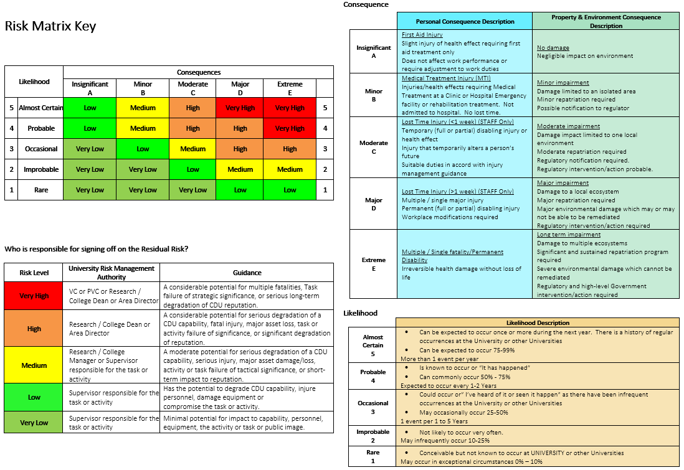

JSEA ACCEPTANCE
In signing below, I confirm that:
I have read this JSEA and / or it has been explained to me. I clearly understand and have accepted its contents.
I clearly understand that the controls in this JSEA must be applied as documented; otherwise work is to cease immediately.

Name | Position | Signature | Date
 |  |  | / /
 |  |  | / /
 |  |  | / /
 |  |  | / /
 |  |  | / /
 |  |  | / /
 |  |  | / /
 |  |  | / /
 |  |  | / /
 |  |  | / /
 |  |  | / /
 |  |  | / /
 |  |  | / /
 |  |  | / /

Attachment A
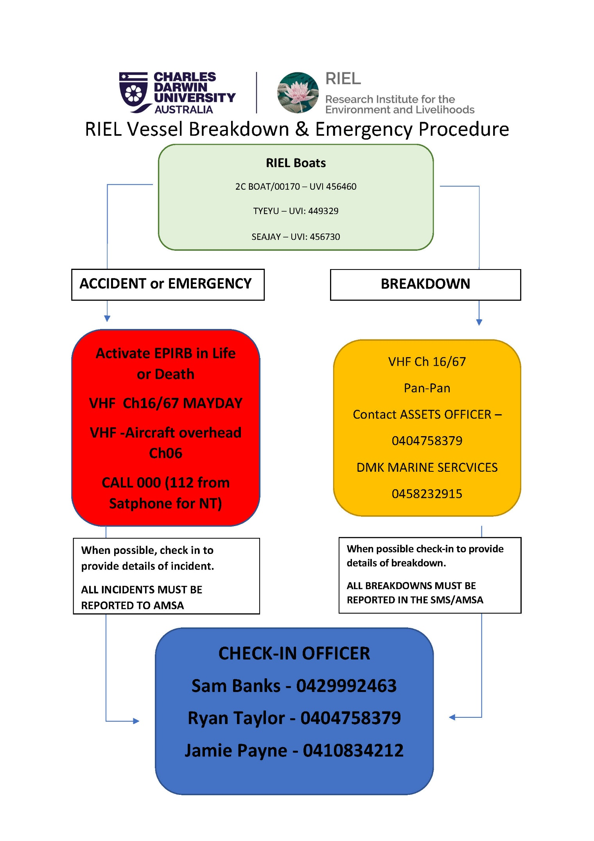
Attachment B
FIELDWORK EQUIPMENT CHECKLIST

This guide is provided to assist you in preparing the necessary equipment required for your fieldwork activity, the list is not exhaustive, a detailed list should be prepared and discussed with all participants in preparation for fieldwork. Having the necessary equipment will help you better manage emergencies and mitigate potential risks.

*Every trip must have reliable communication equipment to ensure they can periodically check-in and/or contact the CDU base and/or emergency services, as needed.

Copy of Fieldwork Activity Risk Assessment
Fieldwork Plan
Satellite phone
VHF radios
GPS (+spare batteries)
4WD remote recovery equipment
First Aid Kit (suitable for the trip)
Minimum 5L of drinking water per person per day (plus additional personal water bottles
Food (appropriate for the conditions and length of time)
Appropriate utensils and cooking gear
Sun protection cream
Hats
Spare socks
Raincoats
Paper maps
Wet wipes
Hand sanitizer
Bug repellent
Plastic bags for rubbish
Sharps container
Sample jars
Soft measuring tapes

Zip ties
Trail marker tape
Shovel
Hatchet
Head lamps
Extra batteries
Esky
Pillows
Swags
Laptop and charger
Phone chargers
Go pro and charger
Camera
Toilet paper
Paper pens
Field logs
Other recovery gear
Other
PPE Specific to the tasks to be conducted
Relevant Safe Work Procedures for the tasks to be conducted

Attachment C
Emergency Response and Safety Plan
- Personal InJURY
In the event of a significant personal Injury, where emergency assistance is required, please adopt the following procedures:
- The first person at the scene should assess DANGER to self, patient, and bystanders. If safe to proceed, assess response of patient and immediately seek assistance from the in-field leader. A decision must be made immediately on the severity and type of assistance.

- The first person at the scene should provide the following information to all contacted emergency responders upon contact (000, RFDS, Research Supervisor):
- Caller’s name and satellite phone number
- Location of incident (i.e. GPS location, map reference)
- Number of persons involved
- Nature and severity of injuries
- Any first aid management applied
- Nature of calls previously made
- Number of available resources, able-bodied people, water, food, shelter, and vehicles
- Agree on the pre-determined meeting place for the evacuation.

Note: If you are unable to get to one of the pre-determined meeting places, promptly inform your emergency responders.

- MISSING PERSON(S)

If a person(s) goes missing whilst working in the field remotely, the procedure below must be followed:

- The onsite activity leader (or if the Onsite Activity Leader is missing, another person in the group) should attempt to contact the missing team member(s) via mobile or satellite phone, whichever is available.

- If there is no response, the Onsite Activity Leader, or the most senior person in the group must contact Emergency 000 (or 112 from a satellite phone), and provide the following information:

- Caller’s name and phone number (mobile or satellite)
- Current location (i.e. GPS location, map reference)
- Name(s) of person(s) missing
- Time of last contact with missing person(s)
- Location of person(s) when last contacted
- Possible direction the missing person is heading
- Personal information regarding pre-existing medical conditions and any medication being taken
- Number of available resources, such as able-bodies people, water, food, shelter, and vehicles.
- DO NOT LEAVE YOUR POSITION, unless you are in imminent danger – wait for responding Emergency Services.

- The onsite activity leader (or if the Onsite Activity Leader is missing, the most senior person in the group) must contact the check-in contact, The Faculty Manager (08 89466550) or the Faculty PVC (08 89466094) immediately. If afterhours, the Faculty Emergency number: 0447 030 329.

- If unable to contact any of the officers above contact the CDU HSE (0435 691 871) or the Critical Incident Controller (CIC) (0409 096 268).

- After the call with Emergency Services, the activity leader should continue to try and contact the missing person until further advice.

NOTE: all emergencies to be notified to the Faculty Manager and the Faculty PVC as soon as practicably possible.

Attachment D
FIELDWORK APPROVAL PROCEDURE
1. Consult Fieldwork Guidance Materials
2. Complete Fieldwork Participants Form
To be completed at the beginning of each year
Register your travel through CTM with the necessary approvals. Book relevant CDU vehicle and other equipment. Conduct relevant Risk Assessments as required.
3. Complete Fieldwork Plan and Risk Assessment
4. Send all completed forms to
fst-support@cdu.edu.au for approval (Allow 2 weeks prior to travel for approvals and processing)
5. Faculty admin team will arrange PVC approvals if required
A calendar reminder and approved forms are entered into the calendar of the check-in officer to confirm awareness of travel and check-in schedule. Forms will be kept for information and record-keeping.

Continue fieldwork assessment and approval process
Location within Australia
No
Yes
Yes
DFAT Advisory – www.dfat.gov.au
Print DFAT travel advisory for destination/transit countries
Complete DFAT MEMO and Declaration to be approved by the VC
DFAT Advisory reconsider need to travel
Complete all smart traveller requirements www.Smarttraveller.gov.au
No
3.1 Enter trip details in ‘SMART APPROVE’ through CTM
(2 weeks prior to the travel)
3.2 CTM Approval
TRAVEL CAN PROCEED
<50km from base
No
Yes
Fieldwork application and approvals procedure
FST Responsibilities
Onsite Activity Leader (OAL)
Fieldwork Participants
Discipline Chair
FST Admin Team

Attachment E
*Supervisor of the Onsite Activity Leader (OAL) are generally the check-in point of contact. If another officer is selected as the check-in contact the OAL must ensure that they are familiar with check-in and emergency procedures
Approved fieldwork forms are placed in the check-in calendar
The travel details are given to the nominated check-in person
Check-in occurs at the time on the fieldwork form
(SMS preferred)
Yes
Nominated check in person responds to check-in
End of check-in procedure
Check-in contact makes two attempts to contact the onsite activity leader 45 mins and 1 hour after the initial check-in time. If no response on second attempt, check-in contact person attempts to contact other fieldwork participants and other contacts identified on the fieldwork plan, such as accommodation.
Contact is made
Failure to check-in procedure enacted
No
Check-in contact notifies the Faculty Emergency Number on 0447 030 329. If Faculty contact can’t be reached, call Health, Safety and Environment (HSE) on 0435 691 871
Faculty Emergency Contact will escalate accordingly.
If no response contact CDU CIC directly on 0409 096 268
Contact is made
Nominated check in person completes fail to check-in report.
Onsite activity leader completes an accident, incident and injury report
Faculty Pro Vice-Chancellor or Faculty Manager contacts discipline chair/director at their discretion.
Yes
No
CDU Critical Incident Controller (CIC) determines the emergency response in consultation with Faculty Management
FIELDWORK CHECK-IN PROCEDURE*
FST Responsibilities
Onsite Activity Leader (OAL)
Nominated check in person
FST Admin Team
Faculty Manager/PVC
Nominated check in person completes fail to check-in report
Yes
No

Attachment F
EMERGENCY/INCIDENT ASSISTANCE AND REPORTING PROCEDURE*
*All other emergencies or incidents should be reported to the Check-in Contact in the first place, who will escalate accordingly.
Onsite Activity Leader (OAL) assesses the situation
If the emergency is life threatening, a serious injury or ailment, or missing person the OAL follows the Emergency Response Plan.
Accident or Emergency - call 000 (or 112 from satellite phone) immediately
If in the water, ask for WATER POLICE
For non-emergency Police assistance call 131 444
Environmental Emergencies (cyclone, fires, etc.)
Critical: 000
Information: 08 8999 3473 or
https://www.pfes.nt.gov.au/incidentmap - https://securent.nt.gov.au/alerts
Vehicle breakdowns
In the first instance call the relevant roadside assistance
Within the Darwin metropolitan area AANT Roadside Assist Call 131 111
Remote breakdowns contact - 0427 297 211
Call Facilities – 08 8946 6500 (after hours or on weekend the phone is diverted to a Facilities Staff member on call)
Boat breakdowns / assistance
In the first instance call
Marine Assist
0417 765 772
OAL to notify the check-in contact as soon as is practicably possible
Check-in contact to notify/pass on to Faculty Admin
Faculty Admin will assist if any of the above are not available

Personal injury or missing person

Boats
Vehicles

All incidents must be reported to FST and the HSE team. If required, the incident will be reported to the appropriate regulator e.g., NT Worksafe.

